PROJECT REPORT : THE TRAGEDY OF FLIGHT – A COMPREHENSIVE ANALYSIS

***Submitted by:***

**E**. **ABINAYA**

REG.NO- 12020U25001

**P. BAKKIYALAKSHMI**

REG.NO- 12020U25002

**S.DEEPA**

REG.NO- 12020U25003

**V.DHANA LAKSHMI**

REG.NO- 12020U25005

**N.YUVALAKSHMI**

REG.NO- 12020U25037

**DEPARTMENET OF BACHELOR OF SCIENCE IN MATHEMATICS**

PROJECT REPORT

**1.INTRODUCTION:**

1.1. OVERVIEW

1.2. PURPOSE

**2.PROBLEM DEFINITION & DESIGN THINKING:**

2.1. EMPATHY MAP

2.2. IDEATION & BRAINSTORMING MAP

**3.RESULT:**

3.1.DASHBOARD

3.2.STORY

**4. ADVANTAGES AND DIS ADVANTAGES**

4.1. ADVANTAGES

4.2. DIS ADVANTAGES

**5.APPLICATIONS :**

**6.CONCLUSION:**

**7.FUTURE SCOPE:**

**8.APPENDIX:**

8.1. SQL SOURCE CODE

8.2. HTML SOURCE CODE

**1.INTRODUCTION:**

1.1. OVERVIEW

**An airplane crash analysis is a detailed investigation into the causes of an aviation accident .The goal of an airplane crash analysis is to identify any factors that contributed to the accident, with the ultimate goal of improving safety and preventing future accidents. The process of conducting an airplane crash analysis, typically involves the collection and analysis of a wide range of the data including information about the aircraft and its systems the operator and any other relevant factors.**

1.2. PURPOSE

**In this project, our important purposes are to improving aviation safety and preventing similar accidents in the future.**

**2.PROBLEM DEFINITION & DESIGN THINKING:**

2.1. EMPATHY MAP

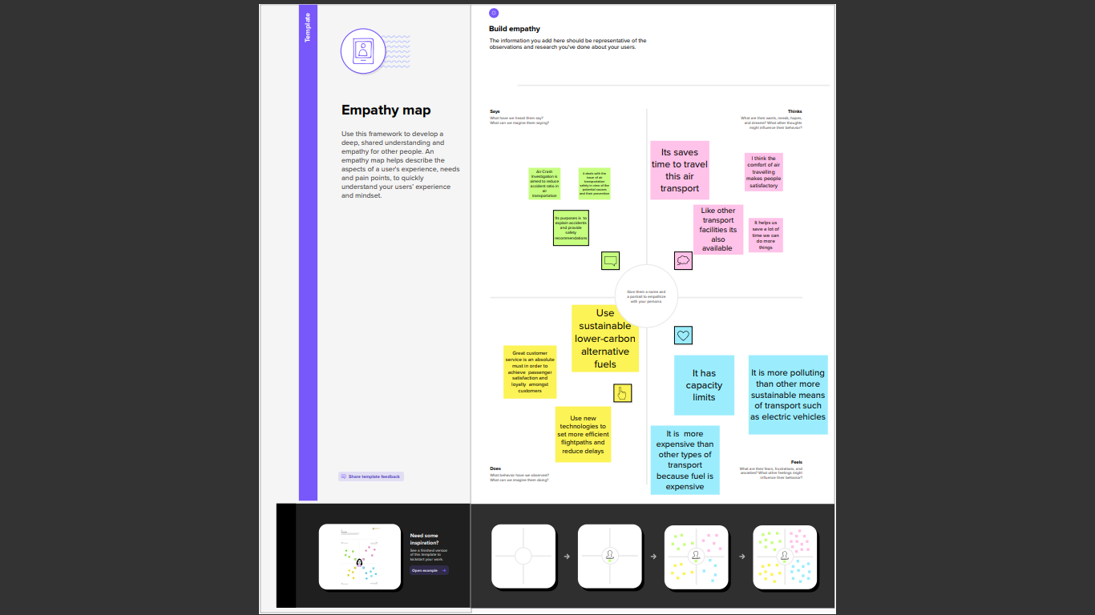

2.2. IDEATION & BRAINSTORMING MAP

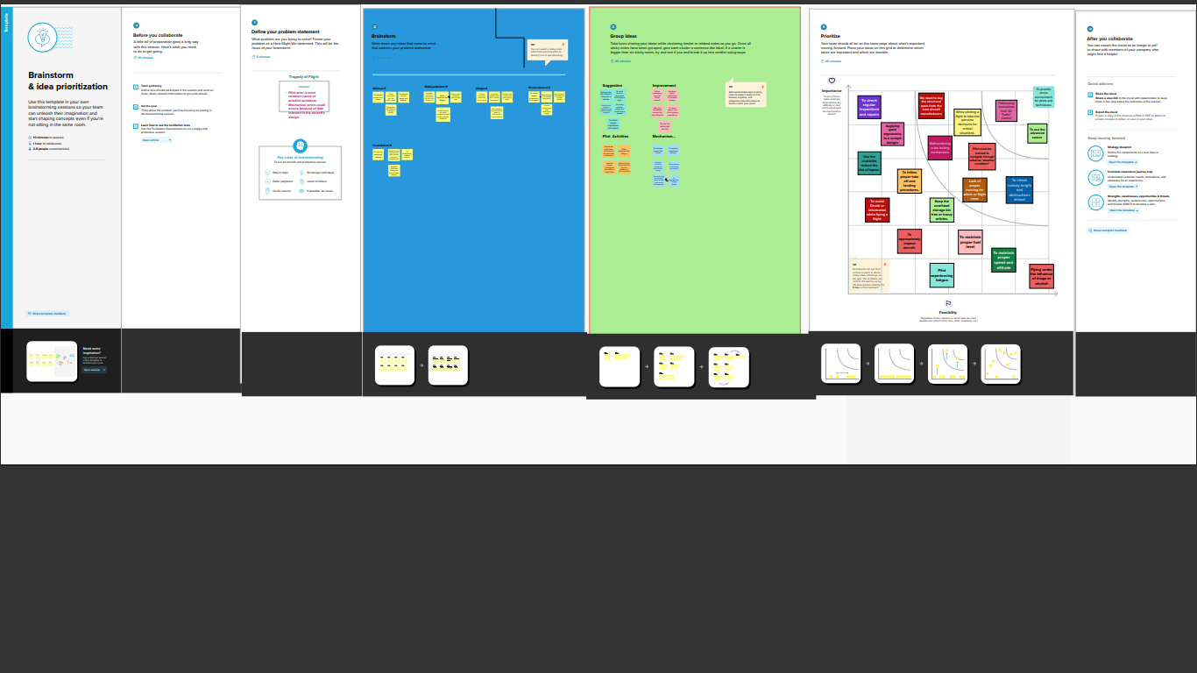

**3.RESULT:**

3.1.DASHBOARD

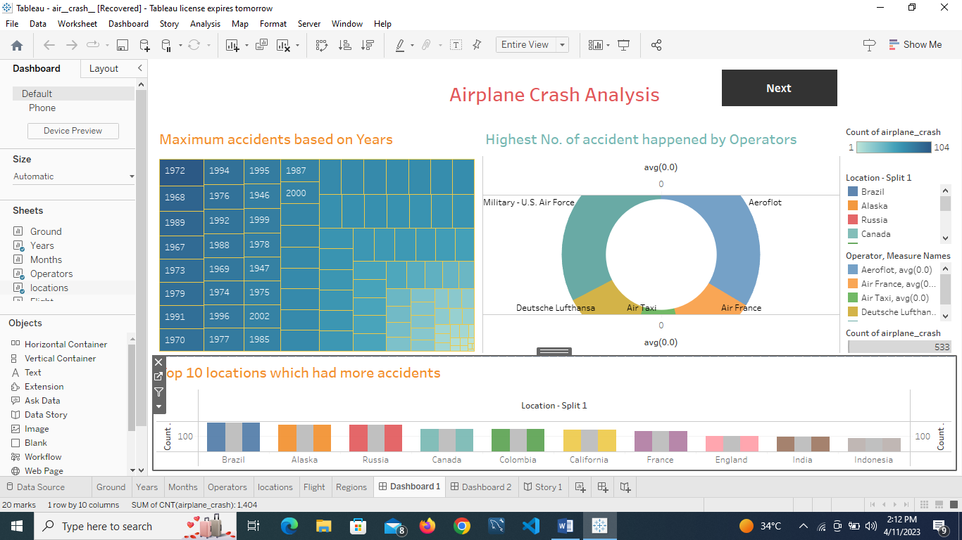

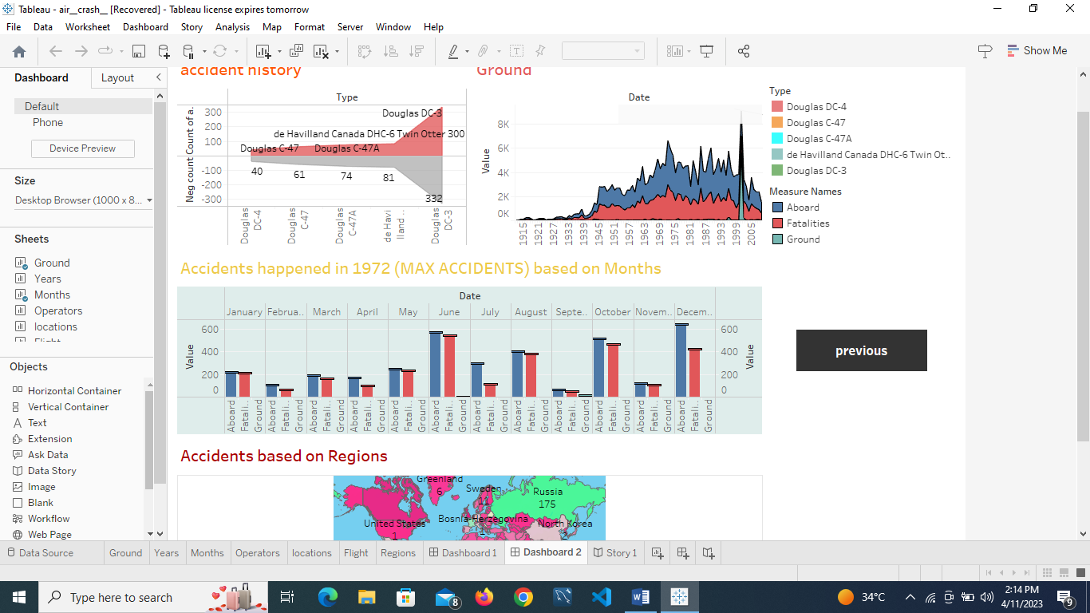

3.2.STORY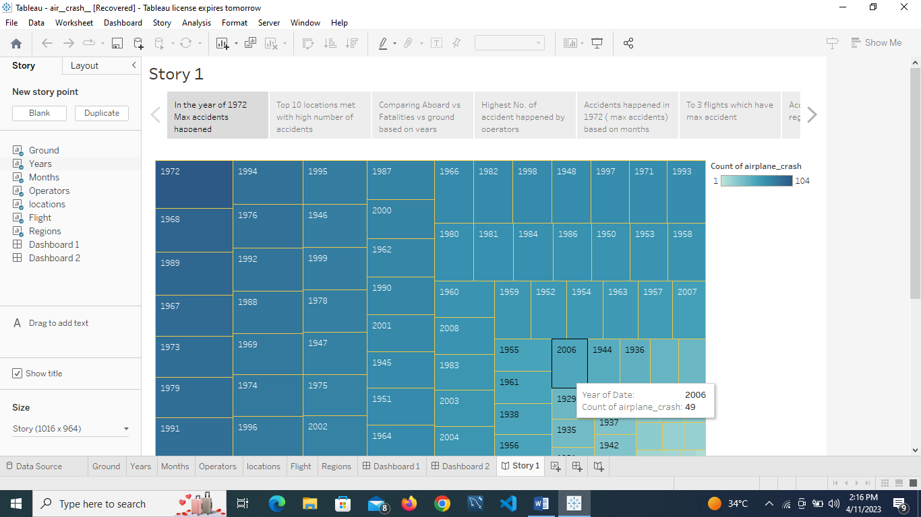

3.3.WEB APPLICATION

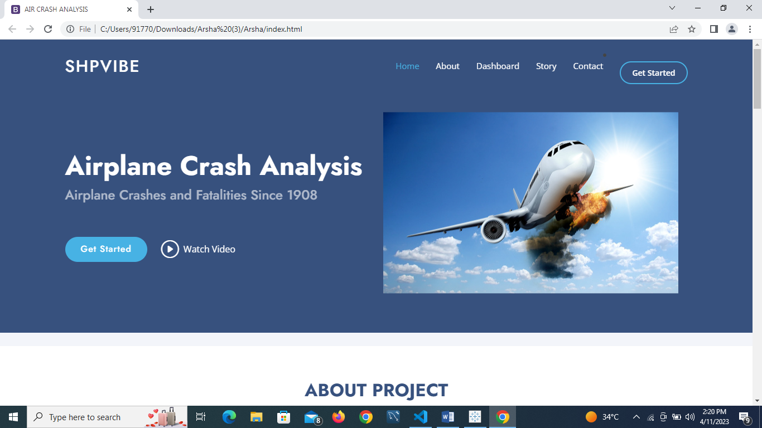

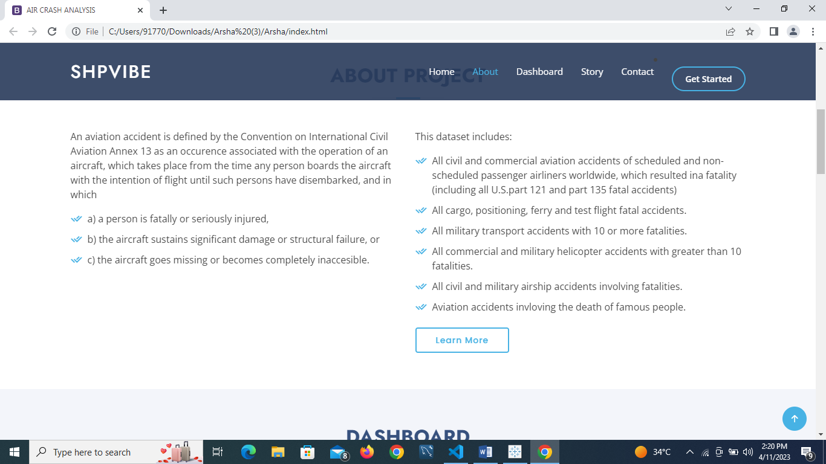

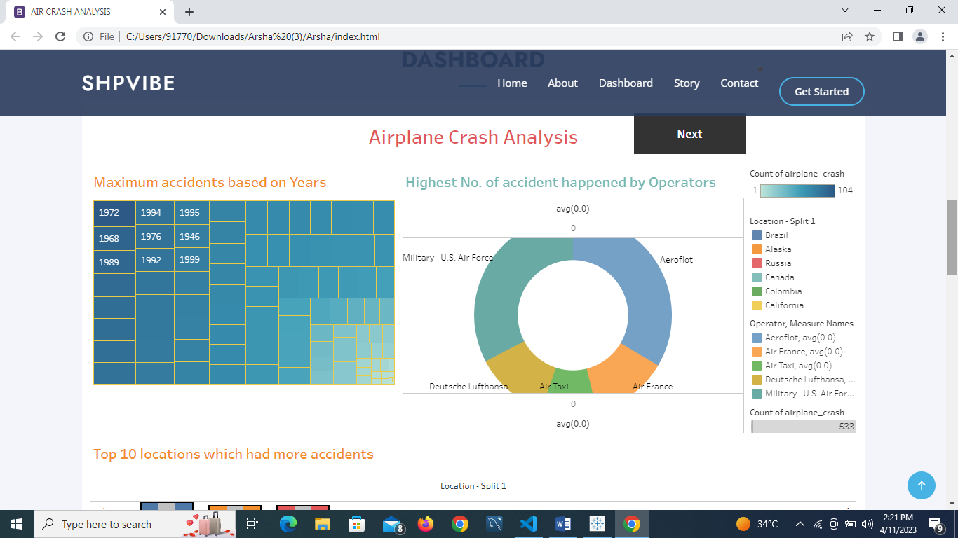

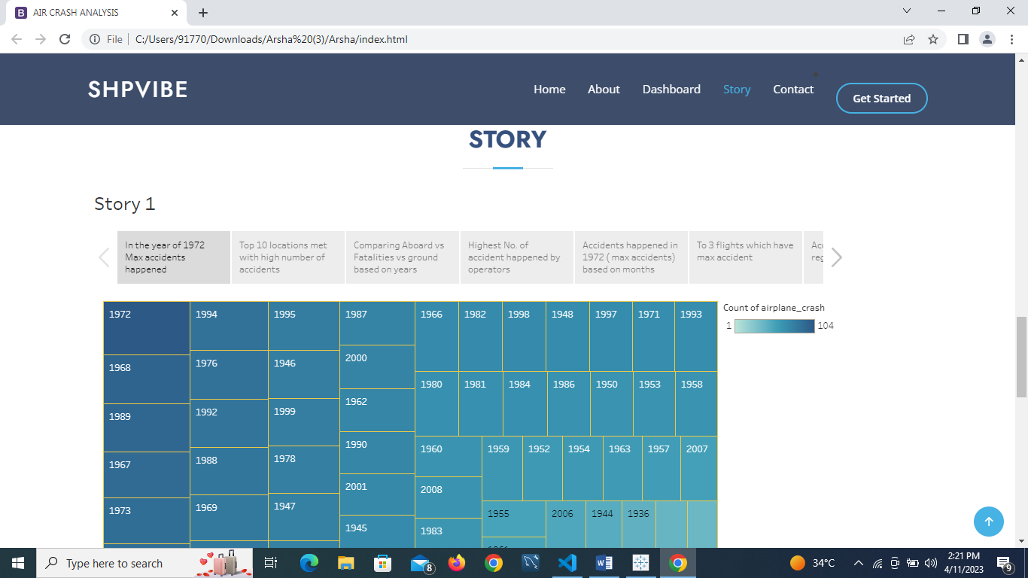

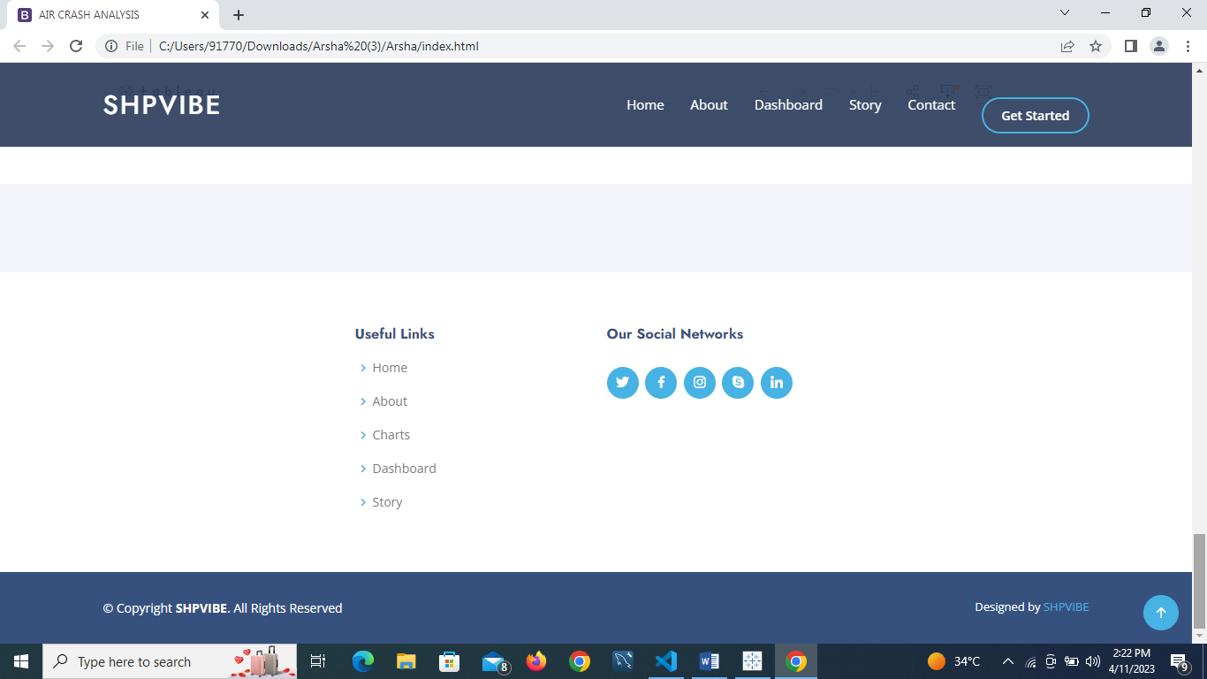

**4. ADVANTAGES AND DIS ADVANTAGES :**

4.1. ADVANTAGES

**The purpose of Crash data is to help decision – makers understand the nature, causes, and injury outcomes of crashes.**

4.2. DIS ADVANTAGES

**The report should include both immediate causes - such as active failures of pilots are maintenance crew - and underlying reasons, like insufficient training or pressure to rush through a task.**

**5.APPLICATIONS :**

**Use the advanced sensors, and applying good ergonomics to a cockpit designs and maintain the speed, altitude and malfunctioning in the lacking of mechanisms .**

**6.CONCLUSION:**

**The goal is to locating the priority of crucial evidence in the block boxes to reconstruct the simulations of information analysis of the air crash plane.**

**7.FUTURE SCOPE:**

**Aviation accident analysis is an important part of aviation safety research. We used long term sequence aviation accident statistics to analyze the characteristics of historical aviation accidents and predict the future direction of aviation accidents.**

**8.APPENDIX:**

8.1. SQL SOURCE CODE

create schema tragedy flight;

use tragedy flight;

select * from airplane_crash;

8.2 HTML CODE

<!DOCTYPE html>

<html lang="en">

<head>

  <meta charset="utf-8">

  <meta content="width=device-width, initial-scale=1.0" name="viewport">

  <title>AIR CRASH ANALYSIS</title>

  <meta content="" name="description">

  <meta content="" name="keywords">

  <!-- Favicons -->

  <link href="assets/img/favicon.png" rel="icon">

  <link href="assets/img/apple-touch-icon.png" rel="apple-touch-icon">

  <!-- Google Fonts -->

  <link href="https://fonts.googleapis.com/css?family=Open+Sans:300,300i,400,400i,600,600i,700,700i|Jost:300,300i,400,400i,500,500i,600,600i,700,700i|Poppins:300,300i,400,400i,500,500i,600,600i,700,700i" rel="stylesheet">

  <!-- Vendor CSS Files -->

  <link href="assets/vendor/aos/aos.css" rel="stylesheet">

  <link href="assets/vendor/bootstrap/css/bootstrap.min.css" rel="stylesheet">

  <link href="assets/vendor/bootstrap-icons/bootstrap-icons.css" rel="stylesheet">

  <link href="assets/vendor/boxicons/css/boxicons.min.css" rel="stylesheet">

  <link href="assets/vendor/glightbox/css/glightbox.min.css" rel="stylesheet">

  <link href="assets/vendor/remixicon/remixicon.css" rel="stylesheet">

  <link href="assets/vendor/swiper/swiper-bundle.min.css" rel="stylesheet">

  <!-- Template Main CSS File -->

  <link href="assets/css/style.css" rel="stylesheet">

  <!-- =======================================================

  * Template Name: Arsha

  * Updated: Mar 10 2023 with Bootstrap v5.2.3

  * Template URL: https://bootstrapmade.com/arsha-free-bootstrap-html-template-corporate/

  * Author: BootstrapMade.com

  * License: https://bootstrapmade.com/license/

  ======================================================== -->

</head>

<body>

  <!-- ======= Header ======= -->

  <header id="header" class="fixed-top ">

    <div class="container d-flex align-items-center">

      <h1 class="logo me-auto"><a href="index.html">SHPVIBE</a></h1>

      <!-- Uncomment below if you prefer to use an image logo -->

      <!-- <a href="index.html" class="logo me-auto"><img src="assets/img/logo.png" alt="" class="img-fluid"></a>-->

      <nav id="navbar" class="navbar">

        <ul>

          <li><a class="nav-link scrollto active" href="#hero">Home</a></li>

          <li><a class="nav-link scrollto" href="#about">About</a></li>

          <li><a class="nav-link scrollto" href="#Dashboard">Dashboard</a></li>

          <li><a class="nav-link   scrollto" href="#Story">Story</a></li>

          <li><a class="nav-link scrollto" href="#Contact">Contact</a></li>

            </ul>

          </li>

          <li><a class="getstarted scrollto" href="#about">Get Started</a></li>

        </ul>

        <i class="bi bi-list mobile-nav-toggle"></i>

      </nav><!-- .navbar -->

    </div>

  </header><!-- End Header -->

  <!-- ======= Hero Section ======= -->

  <section id="hero" class="d-flex align-items-center">

    <div class="container">

      <div class="row">

        <div class="col-lg-6 d-flex flex-column justify-content-center pt-4 pt-lg-0 order-2 order-lg-1" data-aos="fade-up" data-aos-delay="200">

          <h1>Airplane Crash Analysis</h1>

          <h2>Airplane Crashes and Fatalities Since 1908</h2>

          <div class="d-flex justify-content-center justify-content-lg-start">

            <a href="#about" class="btn-get-started scrollto">Get Started</a>

            <a href="https://www.youtube.com/watch?v=jDDaplaOz7Q" class="glightbox btn-watch-video"><i class="bi bi-play-circle"></i><span>Watch Video</span></a>

          </div>

        </div>

        <div class="col-lg-6 order-1 order-lg-2 hero-img" data-aos="zoom-in" data-aos-delay="200">

          <img src="C:\Users\91770\Downloads\Flight image.jpg" class="img-fluid animated" alt="">

        </div>

      </div>

    </div>

  </section><!-- End Hero -->

  <main id="main">

    <!-- ======= Clients Section ======= -->

    <section id="clients" class="clients section-bg">

      <div class="container">

        <div class="row" data-aos="zoom-in">

        </div>

      </div>

    </section><!-- End Cliens Section -->

    <!-- ======= About Us Section ======= -->

    <section id="about" class="about">

      <div class="container" data-aos="fade-up">

        <div class="section-title">

          <h2>ABOUT PROJECT</h2>

        </div>

        <div class="row content">

          <div class="col-lg-6">

            <p>

             An aviation accident is defined by the Convention on International Civil Aviation Annex 13 as an occurence associated with the operation of an aircraft,

             which takes place from the time any person boards the aircraft with the intention of flight until such persons have disembarked, and in which

            </p>

            <ul>

              <li><i class="ri-check-double-line"></i> a) a person is fatally or seriously injured,</li>

              <li><i class="ri-check-double-line"></i>b) the aircraft sustains significant damage or structural failure, or</li>

              <li><i class="ri-check-double-line"></i> c) the aircraft goes missing or becomes completely inaccesible.</li>

            </ul>

          </div>

          <div class="col-lg-6 pt-4 pt-lg-0">

            <p>

             This dataset includes:

            </p>

            <p>

              <ul>

            <li><i class="ri-check-double-line"></i> All civil and commercial aviation accidents of scheduled and non-scheduled passenger airliners worldwide, which resulted ina fatality (including all U.S.part 121 and part 135 fatal accidents)</li>

             <li><i class="ri-check-double-line"></i> All cargo, positioning, ferry and test flight fatal accidents.</li>

             <li><i class="ri-check-double-line"></i> All military transport accidents with 10 or more fatalities.</li>

             <li><i class="ri-check-double-line"></i> All commercial and military helicopter accidents with greater than 10 fatalities.</li>

             <li><i class="ri-check-double-line"></i> All civil and military airship accidents involving fatalities.</li>

             <li><i class="ri-check-double-line"></i> Aviation accidents invloving the death of famous people.</li>

            </p>

          </ul>

             <a href="#" class="btn-learn-more">Learn More</a>

          </div>

        </div>

      </div>

    </section><!-- End About Us Section -->

    <!-- ======= Services Section ======= -->

    <section id="dashboard" class="dashboard section-bg">

      <div class="container" data-aos="fade-up">

        <div class="section-title">

          <h2>Dashboard</h2>

          <p>

            <div <div <div class='tableauPlaceholder' id='viz1680937996145' style='position: relative'><noscript><a href='#'><img alt='Airplane Crash Analysis ' src='https:&#47;&#47;public.tableau.com&#47;static&#47;images&#47;ai&#47;air__crash__&#47;Dashboard1&#47;1_rss.png' style='border: none' /></a></noscript><object class='tableauViz'  style='display:none;'><param name='host_url' value='https%3A%2F%2Fpublic.tableau.com%2F' /> <param name='embed_code_version' value='3' /> <param name='site_root' value='' /><param name='name' value='air__crash__&#47;Dashboard1' /><param name='tabs' value='no' /><param name='toolbar' value='yes' /><param name='static_image' value='https:&#47;&#47;public.tableau.com&#47;static&#47;images&#47;ai&#47;air__crash__&#47;Dashboard1&#47;1.png' /> <param name='animate_transition' value='yes' /><param name='display_static_image' value='yes' /><param name='display_spinner' value='yes' /><param name='display_overlay' value='yes' /><param name='display_count' value='yes' /><param name='language' value='en-US' /><param name='filter' value='publish=yes' /></object></div>                <script type='text/javascript'>                    var divElement = document.getElementById('viz1680937996145');                    var vizElement = divElement.getElementsByTagName('object')[0];                    if ( divElement.offsetWidth > 800 ) { vizElement.style.width='100%';vizElement.style.height=(divElement.offsetWidth*0.75)+'px';} else if ( divElement.offsetWidth > 500 ) { vizElement.style.width='100%';vizElement.style.height=(divElement.offsetWidth*0.75)+'px';} else { vizElement.style.width='100%';vizElement.style.height='1277px';}                     var scriptElement = document.createElement('script');                    scriptElement.src = 'https://public.tableau.com/javascripts/api/viz_v1.js';                    vizElement.parentNode.insertBefore(scriptElement, vizElement);                </script>

          </p>

        </div>

          </div>

        </div>

      </div>

    </section><!-- End Services Section -->

    <!-- ======= Portfolio Section ======= -->

    <section id="Story" class="Story">

      <div class="container" data-aos="fade-up">

        <div class="section-title">

          <h2>Story</h2>

          <p><div class='tableauPlaceholder' id='viz1680886903510' style='position: relative'><noscript><a href='#'><img alt='Story 1 ' src='https:&#47;&#47;public.tableau.com&#47;static&#47;images&#47;ai&#47;air__crash__&#47;Story1&#47;1_rss.png' style='border: none' /></a></noscript><object class='tableauViz'  style='display:none;'><param name='host_url' value='https%3A%2F%2Fpublic.tableau.com%2F' /> <param name='embed_code_version' value='3' /> <param name='site_root' value='' /><param name='name' value='air__crash__&#47;Story1' /><param name='tabs' value='no' /><param name='toolbar' value='yes' /><param name='static_image' value='https:&#47;&#47;public.tableau.com&#47;static&#47;images&#47;ai&#47;air__crash__&#47;Story1&#47;1.png' /> <param name='animate_transition' value='yes' /><param name='display_static_image' value='yes' /><param name='display_spinner' value='yes' /><param name='display_overlay' value='yes' /><param name='display_count' value='yes' /><param name='language' value='en-US' /><param name='filter' value='publish=yes' /></object></div>                <script type='text/javascript'>                    var divElement = document.getElementById('viz1680886903510');                    var vizElement = divElement.getElementsByTagName('object')[0];                    vizElement.style.width='1016px';vizElement.style.height='991px';                    var scriptElement = document.createElement('script');                    scriptElement.src = 'https://public.tableau.com/javascripts/api/viz_v1.js';                    vizElement.parentNode.insertBefore(scriptElement, vizElement);                </script></p>

        </div>

  </main><!-- End #main -->

  <!-- ======= Footer ======= -->

  <footer id="footer">

    <div class="footer-newsletter">

      <div class="container">

        <div class="row justify-content-center">

          <div class="col-lg-6">

            </form>

          </div>

        </div>

      </div>

    </div>

    <div class="footer-top">

      <div class="container">

        <div class="row">

          <div class="col-lg-3 col-md-6 footer-contact">

          </div>

          <div class="col-lg-3 col-md-6 footer-links">

            <h4>Useful Links</h4>

            <ul>

              <li><i class="bx bx-chevron-right"></i> <a href="#">Home</a></li>

              <li><i class="bx bx-chevron-right"></i> <a href="#">About </a></li>

              <li><i class="bx bx-chevron-right"></i> <a href="#">Charts</a></li>

              <li><i class="bx bx-chevron-right"></i> <a href="#">Dashboard</a></li>

              <li><i class="bx bx-chevron-right"></i> <a href="#">Story</a></li>

            </ul>

          </div>

          <div class="col-lg-3 col-md-6 footer-links">

            <h4>Our Social Networks</h4>

            <div class="social-links mt-3">

              <a href="#" class="twitter"><i class="bx bxl-twitter"></i></a>

              <a href="#" class="facebook"><i class="bx bxl-facebook"></i></a>

              <a href="#" class="instagram"><i class="bx bxl-instagram"></i></a>

              <a href="#" class="google-plus"><i class="bx bxl-skype"></i></a>

              <a href="#" class="linkedin"><i class="bx bxl-linkedin"></i></a>

            </div>

          </div>

        </div>

      </div>

    </div>

    <div class="container footer-bottom clearfix">

      <div class="copyright">

        &copy; Copyright <strong><span>SHPVIBE</span></strong>. All Rights Reserved

      </div>

      <div class="credits">

        <!-- All the links in the footer should remain intact. -->

        <!-- You can delete the links only if you purchased the pro version. -->

        <!-- Licensing information: https://bootstrapmade.com/license/ -->

        <!-- Purchase the pro version with working PHP/AJAX contact form: https://bootstrapmade.com/arsha-free-bootstrap-html-template-corporate/ -->

        Designed by <a href="https://bootstrapmade.com/">SHPVIBE</a>

      </div>

    </div>

  </footer><!-- End Footer -->

  <div id="preloader"></div>

  <a href="#" class="back-to-top d-flex align-items-center justify-content-center"><i class="bi bi-arrow-up-short"></i></a>

  <!-- Vendor JS Files -->

  <script src="assets/vendor/aos/aos.js"></script>

  <script src="assets/vendor/bootstrap/js/bootstrap.bundle.min.js"></script>

  <script src="assets/vendor/glightbox/js/glightbox.min.js"></script>

  <script src="assets/vendor/isotope-layout/isotope.pkgd.min.js"></script>

  <script src="assets/vendor/swiper/swiper-bundle.min.js"></script>

  <script src="assets/vendor/waypoints/noframework.waypoints.js"></script>

  <script src="assets/vendor/php-email-form/validate.js"></script>

  <!-- Template Main JS File -->

  <script src="assets/js/main.js"></script>

</body>

</html>